Domain name adding,

Go to the cpanel,
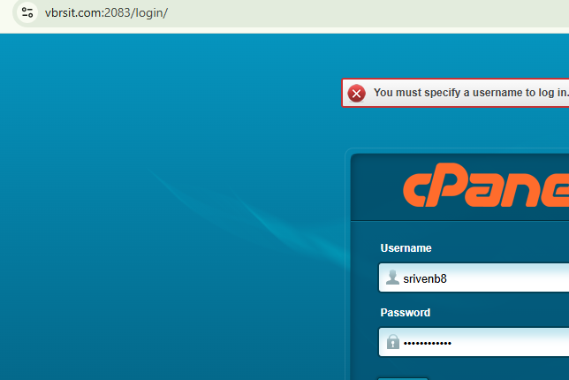

Click on to the domains,
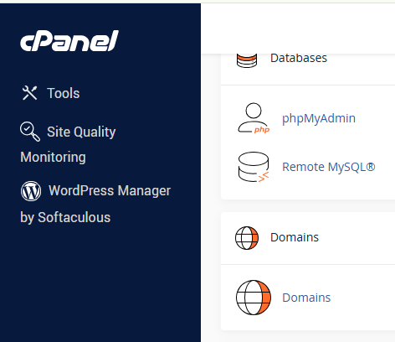

Displayed like this down side,
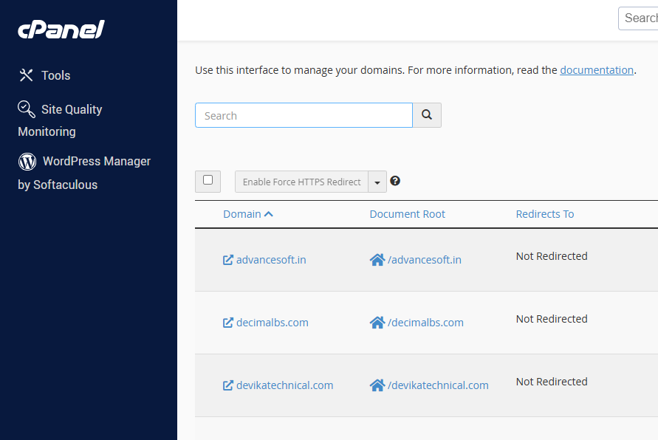

Click on create a new domain name,
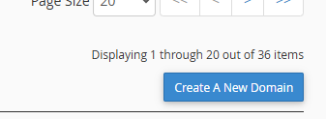

Here give our new domain name what every we need domain name give that one then click on submit,
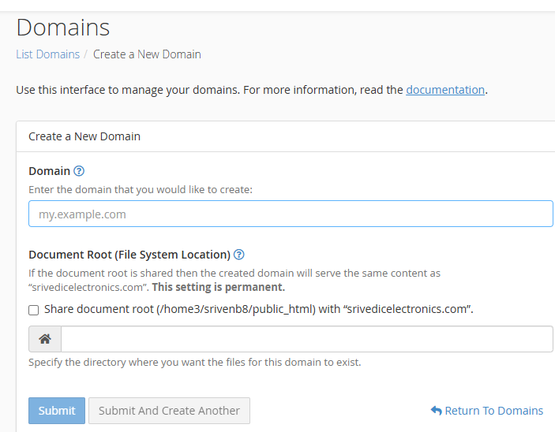

After come to back and go to the zone editor why because perversely we created new domain name here displayed,
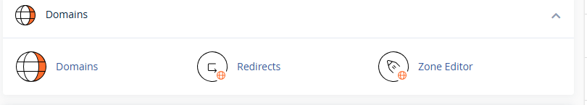

Displayed like this zone editor, then you can search our new domain name then here displayed, then click on manage
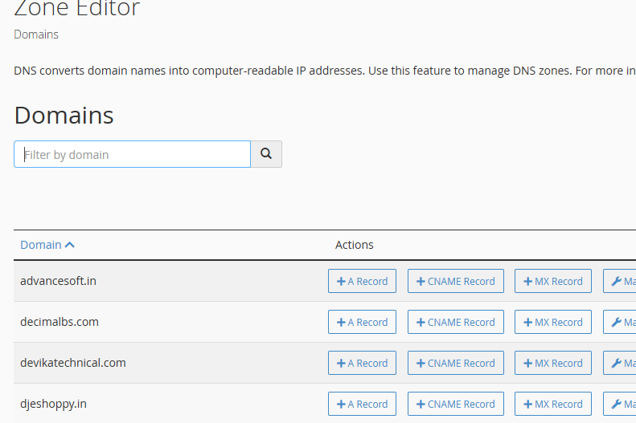

Here add the only public ip address, here not allowed private ipaddress,

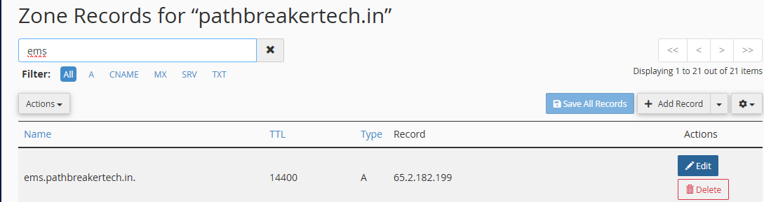

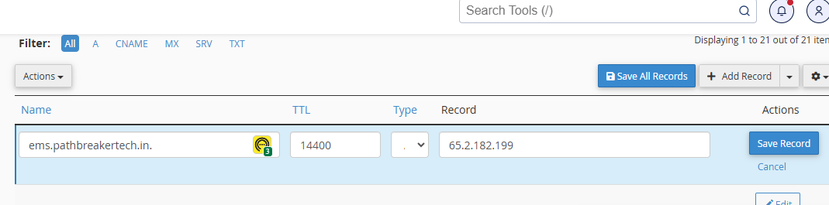

After we do one think that is we have to configuration nginx file add domain name and ssl sets like this down side,

server_name ems.pathbreakertech.in === perversely we can add in this place ipaddress now we have domain name so we can add domain name,

server { listen 80;
listen [::]:80;
server_name ems.pathbreakertech.in; return 301 https://$host$request_uri;}server {
listen 443 ssl;
listen [::]:443 ssl;
server_name ems.pathbreakertech.in;
ssl_certificate /etc/letsencrypt/live/ems.pathbreakertech.in/fullchain.pem; # managed by Certbot
ssl_certificate_key /etc/letsencrypt/live/ems.pathbreakertech.in/privkey.pem; # managed by Certbot
ssl_protocols TLSv1.2 TLSv1.3;
ssl_prefer_server_ciphers on;
ssl_dhparam /etc/letsencrypt/ssl-dhparams.pem; root /var/www/html;
index index.html index.htm; location / {
try_files $uri $uri/ /index.html;
} # Reverse Proxy for Backend (API)
location /ems/ {
proxy_pass https://ems.pathbreakertech.in:9090; # Replace with your backend server's address
proxy_set_header Host $host;
proxy_set_header X-Real-IP $remote_addr;
proxy_set_header X-Forwarded-For $proxy_add_x_forwarded_for;
proxy_set_header X-Forwarded-Proto $scheme;
ssl_certificate /etc/letsencrypt/live/ems.pathbreakertech.in/fullchain.pem; # managed by Certbot
ssl_certificate_key /etc/letsencrypt/live/ems.pathbreakertech.in/privkey.pem; # managed by Certbot } # Reverse Proxy for Backend (API)
location /ems/employee {
proxy_pass https://ems.pathbreakertech.in:8092; # Replace with your backend server's address
proxy_set_header Host $host;
proxy_set_header X-Real-IP $remote_addr;
proxy_set_header X-Forwarded-For $proxy_add_x_forwarded_for;
proxy_set_header X-Forwarded-Proto $scheme;
ssl_certificate /etc/letsencrypt/live/ems.pathbreakertech.in/fullchain.pem; # managed by Certbot
ssl_certificate_key /etc/letsencrypt/live/ems.pathbreakertech.in/privkey.pem; # managed by Certbot }}

